Title (Times New Roman 16 Bold)

First Author (Times New Roman 13 Bold)
Affiliation
Email:

Second and Other Authors (Times New Roman 13 Bold)
Affiliation
Email:

Abstract (Times New Roman 13 Bold) (250-300 Words)
Abstract (Times New Roman 13)
Keywords: 4-6 words

Introduction
Introduction

Research Literature
Research Literature

Materials and Methods
Materials and Methods

Discussion
Discussion

Conclusion
Conclusion

Acknowledgments
Acknowledgments

References
References in APA format

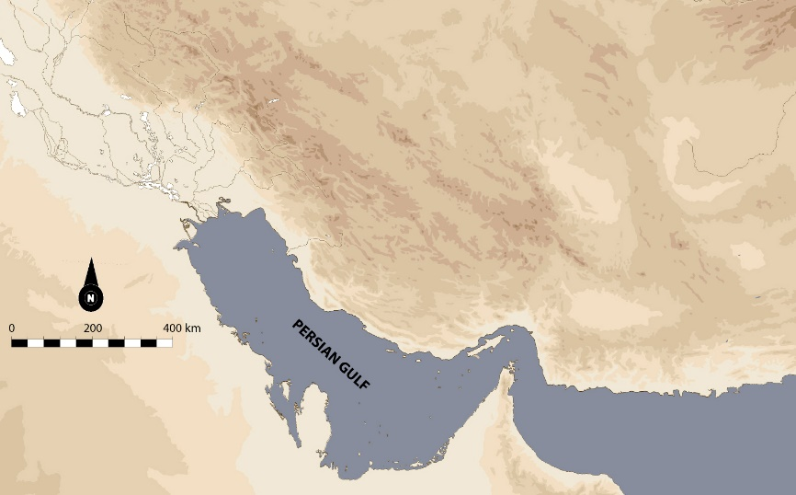
Map 1 -

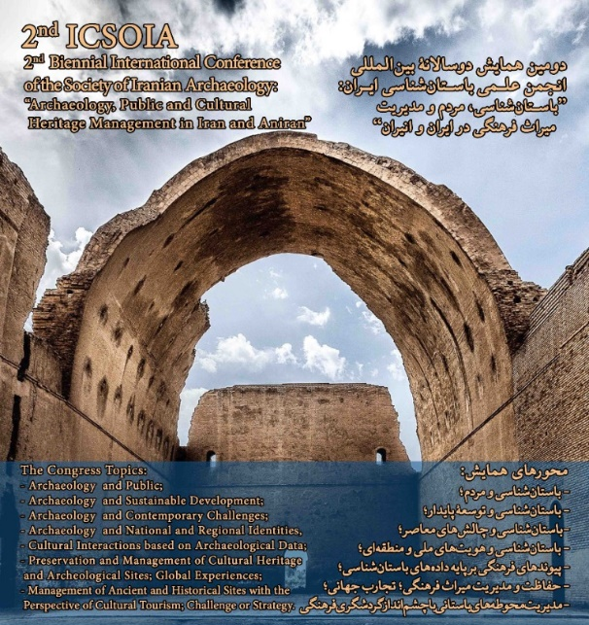
Fig. 1 -

Table 1 -

